Downloading & Installing SonicWALL NetExtender SSL VPN Client

WINDOWS Systems
- Navigate to https://support.cellhire.com/ Navigate to User Guides > Cellhire Customer VPN > SonicWall NetExtender VPN Client

- Choose to download the compatible NetExtender Client for your system

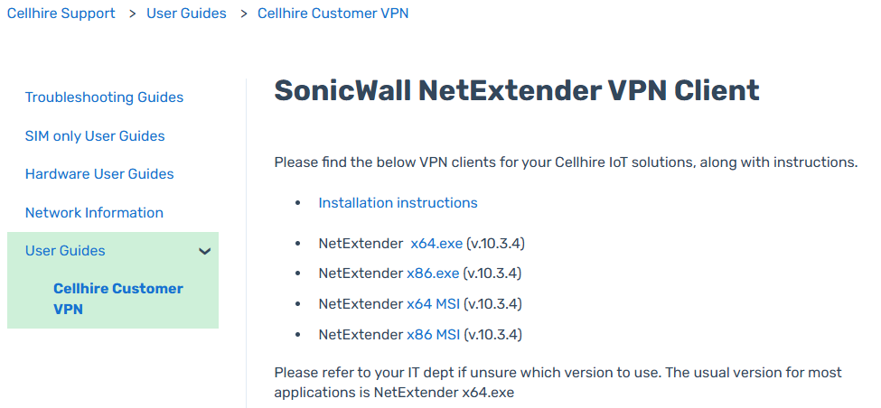

- When the installer is downloaded, run the executable file with appropriate administrative credentials
- Don’t change any of the pre-set default installation values

Apple MacOS Systems
- Browse to https://apps.apple.com/us/app/sonicwall-mobile-connect/id822514576?mt=12

- Click on the download icon and then click Open

- Once the app has been installed it can be opened, follow the below instructions to configure the client

NetExtender SSL VPN Client Configuration (Windows and MacOS)

- Open NetExtender and configure the credentials as follows
Server: vpn.esimsmart.io:4433
Username & Password: As provided
Domain: esimsmart.io
- Click Connect and the client should connect

WINDOWS

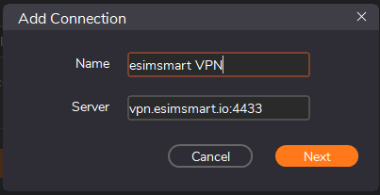
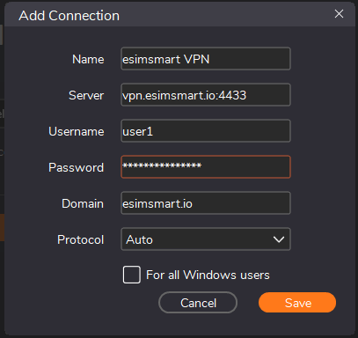

Apple MacOS
